- 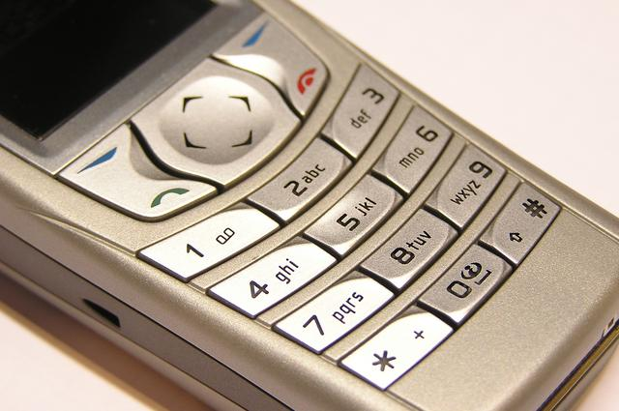

(Enter Name of Your Charity)
Donate your cell phone and other electronics.
For each item donated a monetary contribution will be made to our charity.

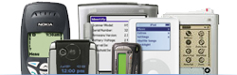
Recycling for charities is an organization committed to protecting the environment by ensuring the proper disposal of mobile phones, ipods, tablets, aircards, and digital cameras. If you are interested in Recycling for Charities or if you would like more information please to contact us at (866) 630-7557or visit our website recyclingforcharities.com

