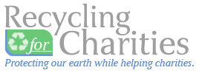
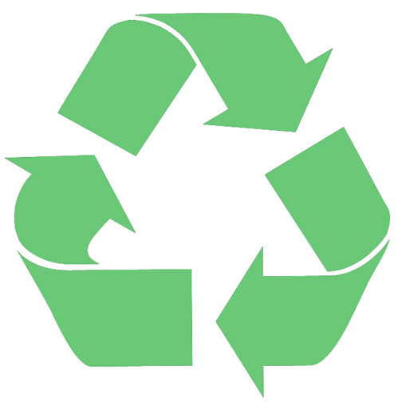
Donation Drive
For

---Insert Organization Name---

---Insert Date--- From ---Insert Date---
About Recycling for Charities  Recycling for Charities is an organization committed to protecting the environment by ensuring proper mobile phone, ipod, tablet, aircard, and digital camera disposal. We provide individuals and corporations across the United States the opportunity to donate old wireless phones and other mobile electronics as part of the larger effort to keep these sources of electronic waste out of landfills. In return for their wireless recycling donation, Recycling for Charities donates money to the charity of the participant’s choice. Charity recycling benefits everyone! | Contact Us  If you are interested in signing up for Recycling for Charities or if you would like more information feel free to contact us.  Recycling for Charities 1898 S. Flatiron Ct Boulder, CO 80301 Tel 866-630-7557 www.recyclingforcharities.com

